
Year 6 Introduction Evening 2025
Parent Information Pack

Year 6: Writing Skills
Skills in the white boxes indicate prior learning. Skills in the coloured boxes indicate end of year expectations.

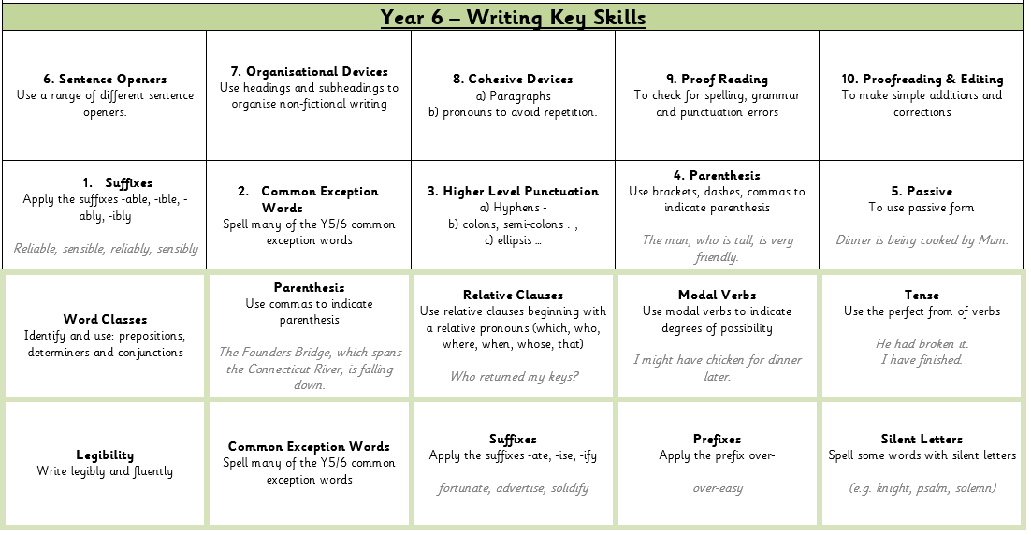

Year 6: Grammar Glossary
Below is an explanation of some of the grammar terminology children are taught in Year 6 (not all of it is new and has been covered in previous years). It is not an exhaustive list of all of the grammatical terms we use but covers the terms that we often have to teach the children in Year 6.

Adverbial Phrase | A phrase built around an adverb. Some adverbial phrases can also be a subordinate clause.  Five minutes later, lunch time ended.  As she took a handful of popcorn, she gazed in awe at the screen.
Antonym | A word with the opposite meaning to another.  good/bad, wise/foolish, long/short
Article | The words the, an and a are articles and are all types of determiner.  ‘The’ is called a definite article because is is used before a specific noun (the dog).  ’An’ and ‘a’ are called indefinite articles because they are used before non-specific nouns (a dog).
Auxiliary Verb | A verb which forms the tense, mood and voice of other verbs. The auxiliary verbs are be, do and have plus all the modal verbs.  For example, be is used to form the progressive tense: I am running.
Brackets | A punctuation mark used to set a non-essential section of the sentence apart (also known as parenthesis).  My friend (who is two years older than me) is coming to my house.
Clause | A phrase which contains a verb. The other words in the clause add meaning to the verb.  There are different types of clause: main clause, subordinate clause and relative clause.
Cohesion | A sentence will have cohesion if all the parts fit together, for example, if the tenses and pronouns are consistent and determiners refer to the correct noun.
Colon | A punctuation mark used in a sentence to indicate that something is about to follow, such as a quotation, an example or a list. A colon can also be used between two main clauses where the second clause explains or expands upon the first in some way.  I need three things at the shop: eggs, milk and break.  He asked for help: he got it.
Comma | A punctuation mark used to separate items in a list and to demarcate clauses.  The warrior was fearless, strong, tall and skilled.  Before picking up his sword, he lifted his heavy shield.
Complex Sentence | Formed by joining a main clause with a subordinate clause using a subordinating conjunction.  I was tired because I had worked all day.
Conjunction | A word that joins clauses. Conjunctions can be co-ordinating or subordinating.  A co-ordinating conjunction joins a main clause to a main clause.  Examples are for, and, nor, but, or, yet, so  A subordinating conjunction joins a main clause to a subordinate clause.  Examples include because, when, as, since, whereas, even though, however, despite
Contraction | Shortened words created by putting two words together, omitting some letters and replacing the omitted letters with an apostrophe.  did not didn’t  was not wasn’t
Dash | Used in a similar way to brackets to set information apart in a sentence. It can also be used in a similar way as a colon to introduce further information  My three friends – Jack, Sam and Callum – are coming for dinner.  There were beautiful things everywhere – china figures, glass animals and delicate tea sets.
Determiner | Used before a noun and its adjectives to help tell you which person or thing the sentence is about, or how much/how many of them there are.  Articles: a/an, the  Demonstratives: this, that, these, those  Possessives: my, your, his, her, its  Quantifiers: fewer, many, much, most, some  Numbers: one, two, three etc.
Direct Speech | When a person’s exact words are written down inside inverted commas.  “Grammar is so exciting,” exclaimed Miss Helm.
Embedded Clause | A clause used in the middle of another clause. It is usually marked by commas.  The man, walking along with his dog, hummed merrily.
Ellipsis | Three dots which are used to show missing words or to create a pause for effect.  Please … tell me what happened.
Fronted Adverbial | An adverb or adverbial phrase used at the beginning of a sentence which is used to describe the action that follows. A fronted adverbial is followed with a comma.  With a scream, she stormed into the room.
Homophone | Words that sound the same but have different meanings and sometimes different spellings.  they’re/their/there, which/witch, where/wear
Hyphen | Can be used to join two or more words that should be read as a single unit (fair-haired) to help avoid confusion (a man eating fish; a man-eating fish) sometimes between a prefix and a root word, especially if the hyphen makes the word easier to read (co-ordinating or re-educate).
Inverted Commas | Punctuation marks used to demarcate direct speech in a sentence. Also known as speech marks.  “How delightfully exciting grammar is!” Miss Siddorn exclaimed.
Main Clause | The leading clause in a sentence which indicated the main subject and verb. It can stand alone without any additional clauses.  I will go for a walk.  Even though the weather is bad, I will go for a walk.
Modal Verb | A verb which affects the other verbs in a sentence by showing:  Obligation (You should do your homework)  Possibility (I might have a pizza for dinner)  Permission (You may leave now)
Object | The object of a sentence is involved in the action but does not carry it out.  I dropped my cup on the floor.
Parenthesis | A word or phrase that is separated from the main part of the sentence as an explanation. Parenthesis is demarcated by brackets, commas or dashes.  Suddenly, from the shadows, a creature crept forward.
Passive Voice | You can tell that a sentence is passive because:  - The subject of the verb has the action done to it.  - There is a part of the verb ‘to be’ (such as was or is) or a verb like ‘get’ followed by the past participle.  - The person or thing carrying out the action is introduced by the word ‘by’ or not at all.  The dog was picked up by his owner.
Past Tense | Any one of a set of verb tenses which describe action that took place in the past.  (see also simple past tense, past perfect tense and past progressive tense)
Past Perfect Tense | A tense used to describe actions that were completed by a certain time in the past. It is formed by using the auxiliary verb ;to have’ (had) + the past participle.  Yesterday, I was late because I had walked to school.  If I had woken up earlier, I would have had breakfast.
Personal Pronoun | A pronoun which replaces a person, place or thing.  he, she, we, they, it, me, him, her, us, them
Phrase | A small group of words that does not contain a verb.
Possessive Apostrophe | An apostrophe to show ownership.  If the owner of the possession ends in:  a single ‘s’ – only an apostrophe is added (Mr Williams’ car)  a double ‘s’ (ss) – an apostrophe and an additional ‘s’ is added (my boss’s chair)  any other letter – an apostrophe and an additional ‘s’ (the girl’s bike)
Possessive Pronoun | A pronoun used to show ownership. Some can be used on their own (mine, yours, his, hers, ours, theirs) whilst others need to be attached to a noun (my, your, her, our, their, whose).
Prefix | Letters that go in front of a root word and change its meaning.  -un + happy = unhappy  -dis + appear = disappear
Preposition | A linking word in a sentence used to show where things are in time and space.  The dinosaur is behind the tree.  Under the table, there is a mouse.
Present Tense | Any one of a set of tenses that describe actions which are happening now.  (see also present perfect tense and present progressive tense)
Proper Noun | A noun which names a particular person, place or thing.  Coten End, London, England, Monday
Reported Speech  (Indirect Speech) | Reported speech focuses more on the content of what someone said rather than their exact words. Inverted commas are not used.  The teacher said that we don’t have any homework today.
Relative Clause | A type of subordinate clause that adapts, describes or modifies a noun by using a relative pronoun.  He ate too many cakes, which made him feel ill.  The wardrobe, that has the fur coats in it, leads to Narnia.
Relative Pronoun | A pronoun used in a relative clause.  who, that, which
Root Word | A basic word with no prefix or suffix added to it.
Semi-colon | A punctuation mark used in a sentence to separate major sentence elements. A semi-colon can be used to join two closely related main clauses if they are not already joined by a co-ordinating conjunction.  My car is red; my friend’s car is blue.  You can also use semi-colons to divide items in a list if the items are long or contain internal punctuation.  You will need to bring the following: sleeping bag, pillow and pyjamas for the overnight stay; water bottle, waterproof jacket, sweatshirt and walking boots for the afternoon trek; and a swimming kit for the river activities.
Simple Sentence | A sentence that contains a subject and one verb.
Singular | Referring to only one. Use of the singular may affect the nouns, verbs and pronouns in a sentence.
Subject | The subject of a sentence is the thing or person carrying out the main action.  The cow ate the grass.
Subordinate Clause | A clause that cannot stand alone as a complete sentence but is linked to a main clause using a subordinating conjunction.  I played out today until it went dark.
Suffix | A string of letters that go at the end of a root word that change or add to its meaning. Suffixes can also show if a word is a noun, verb, adjective or adverb.  noun + -ful = adjective  fear + -ful = fearful  verb + -ment = noun  pay + -ment = payment
Synonym | A word that has exactly or nearly the same meaning as another word.  big/large/huge

Year 6: Writing Examples (Expected Standard)
The following pieces of writing were written towards the end of the year by children judged to be at the expected standard in the summer term. They are annotated with some of the key assessment criteria.

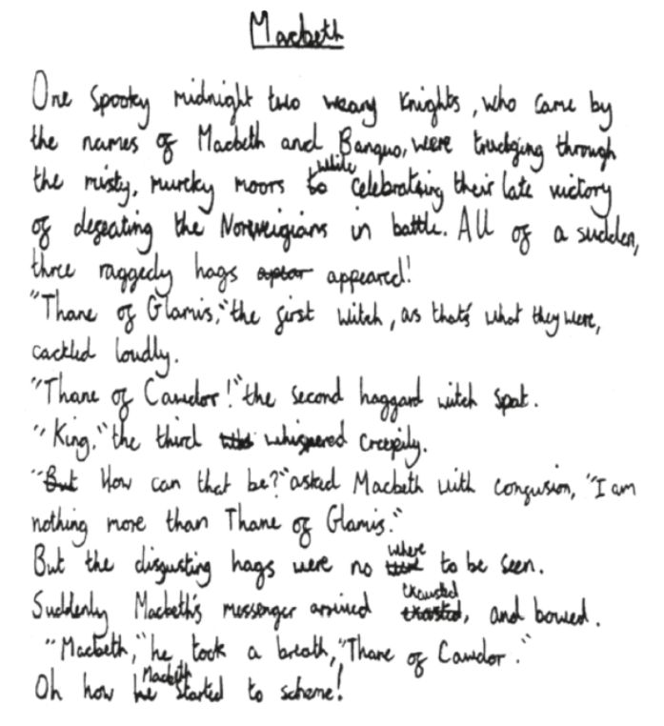
Subordinate clause
Consistent full stops, capital letters, commas, question marks and apostrophes.
Commas for parenthesis
Phrase that adds description of time or place.
Extended narrative following a familiar plot (Macbeth).
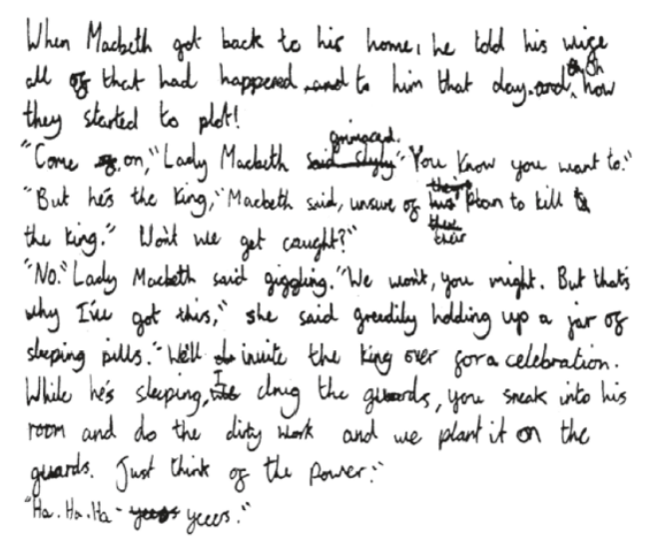
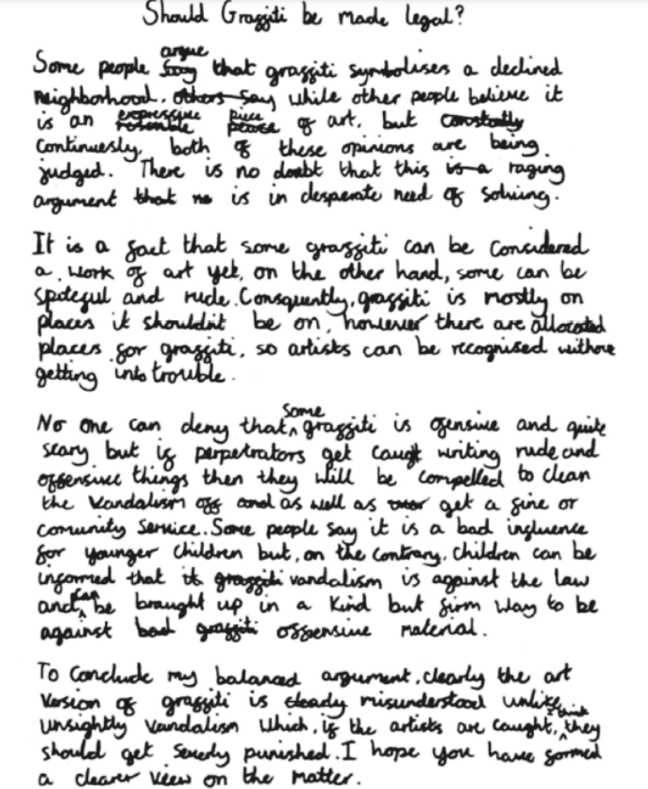
Synonyms
The most common reasons for children’s writing to not achieve the year 6 standard is for there to be too many punctuation errors and for sentences to be consistently simple with little variation of vocabulary or structure.

The annotations show the kind of variation we are looking for.
In Year 6, children are also expected to suit their writing to a much wider range of genres and there is a heavy focus on non-fiction writing as well as narrative.

Children will write balanced arguments, explanation texts, information texts, reviews, instructions and many other variations of non-fiction texts.
Extended non-fiction exploring the debate around graffiti.

Year 6: Mathematics Key Skills
Below is an explanation of all the grammar terminology that is taught to the children during their time in Year 5. Some of these terms are introduced in previous year groups and revisited, whereas some are covered for the first time in Year 6.

Year 6: Maths Key Skills
19. Identify the value of each digit in numbers given to 3 D.P. and multiply and divide numbers by 10, 100 and 1000 giving answers up to 3 D.P. |  | 20. Compare and order fractions, including fractions > 1 | 21. Divide proper fractions by whole numbers |  | 22. Use common factors to simplify fractions |  | 23. perform mental calculations | 24. Multiply simple pairs of proper fractions, writing the answer in its simplest form
14. Recall and use equivalences between simple fractions, decimals and percentages |  | 15. Carry out calculations using all four operations (BODMAS) | 16. Establish whether a number up to 100 is prime and recall prime numbers up to 19 |  |  |  | 17. Express missing number problems algebraically | 18. Multiply one-digit numbers with up to two decimal places by whole numbers.
9. Divide numbers up to 4 digits by a two-digit number using a formal written method of short division | 10. Multiply multi-digit numbers up to 4 digits by a two-digit whole number |  | 11. Identify common factors, common multiples and prime numbers |  |  | 12. Add and subtract numbers with more than 4 digits |  | 13. Read, write, order and compare numbers up to 10,000,000
5. Add and subtract numbers up to 4 digits in a column |  | 6. Order fractions where denominators are all multiples of the same number |  | 7. Know the place value of digits up to 10,000,000 |  |  | 8. Recognise and write decimal equivalents to 1/4, 1/2 and 3/4
1. Know all multiplication and division facts for multiplication tables up to 12 x 12 |  | 2. Multiply and divide whole numbers and those involving decimals by 10, 100 and 1,000 |  |  |  | 3. Read Roman numerals to 1000 (I to C) |  | 4. Find fractions and percentages of quantities

Year 6: Maths Key Skills
20.2 Round whole number to the nearest multiple of 1,000, 100 or 10, and round decimal fractions to the nearest whole number or nearest multiple of 0.01. |  | 21.2 Reason about the location of fractions and mixed numbers in the linear number system. |  |  | 23.2 Recall multiplication and division facts up to 12 x 12. |  | 24.2 Multiply and divide number by 10, 100, 1000, 0.1 and 0.01.
 |  |  |  |  |  |  | 17.2 Use commutativity and inverse operations to manipulate mathematical equations. | 17.3 Be fluent in all Key Stage 2 additive and multiplicative number facts.
 |  |  | 11.2 Find factors and multiples of positive whole numbers. |  |  |  |  | 13.2 Understand the relationship between powers of 10 from 1 hundredth to 1000.
 |  | 6.2 Find equivalent fractions. |  | 7.2 Recognise the place value of each digit in numbers with units from thousands to hundredths.
 |  | 2.2 Divide 1000, 100 and 1 into 2, 4, 5 and 10 equal parts.

Year 6: Calculation Methods
Below are examples of the key calculation methods used in Year 6.

Column Addition  (of up to 4 digit numbers and including decimal numbers to 2 places) | 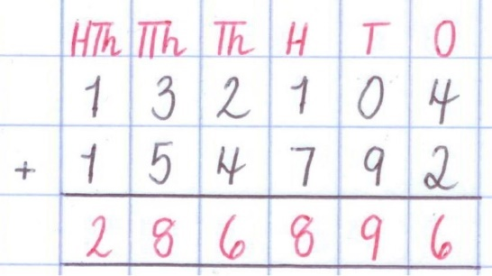  Ensure columns are correctly lined up.  Begin adding from the ones column and work right to left.  No regrouping (carrying over) required.  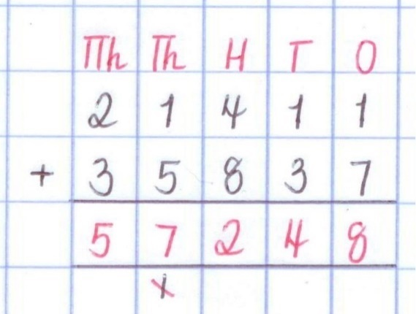  When the total of two number in a column exceeds 9, it crosses the boundary into the next place value column.  In this case, 4 (hundreds) + 8 (hundreds) = 142(hundreds). The 10 hundreds (1 thousand) is carried over beneath the thousands column to be added.  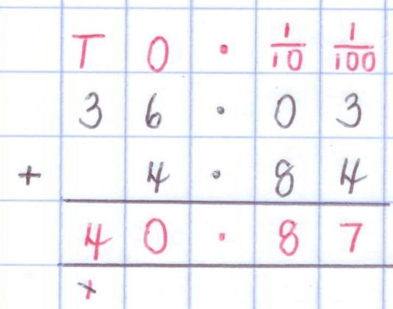  When adding decimals, ensure all columns are correctly in line (including decimal point).  Move decimal point to the answer first and then follow the same method, adding right to left, and regrouping where needed.

Column Subtraction  (of up to 4 digit numbers and including decimal numbers to 2 places) | 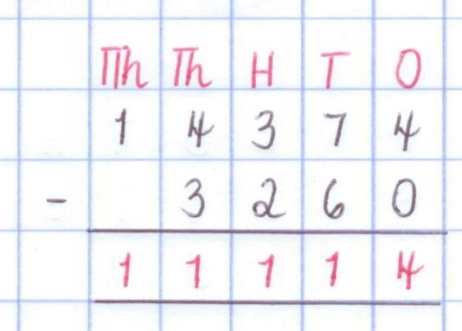  Ensure columns are correctly lined up.  The larger number should be on the top of the calculation.  Subtract right to left (beginning with the ones) ensuring the bottom is always being subtracted from the top (children often swap the numbers over when subtracting).  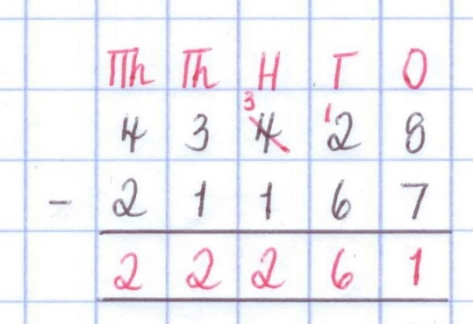  When there is an insufficient amount at the top to subtract the bottom number (without going into negative numbers), we need to exchange (avoid term ‘borrowing’).  In this case, we exchange a hundred for 10 tens. Now we have 12 in the tens column and we are able to subtract 6.  Remind children to change the number in the column that has been exchanged and write it clearly above.  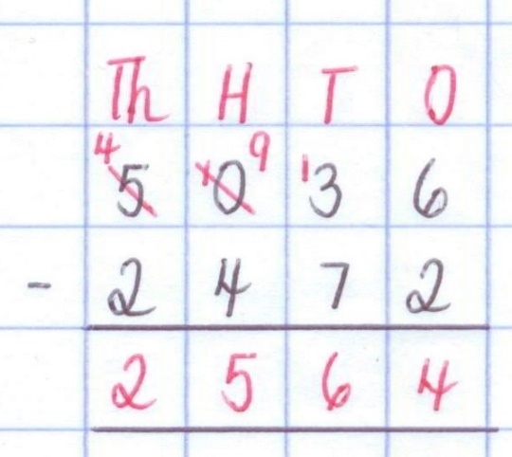  On occasions where an exchange is needed but there is a 0 in the column to the left, we must go to the next column along to exchange.  The exchanged digit can only move one column at a time.  In this case, 1 thousand is exchanged for 10 hundreds. One hundred is then exchanged for 10 tens.
Short Multiplication  (multiplying up to 4 digits by 1 or 2 digits)  Key Vocabulary:  multiplicand: the number being multiplied.  multiplier: the number by which another number is being multiplied.  product: the result of multiplying two or more numbers. | 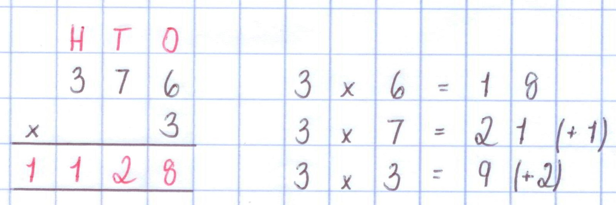  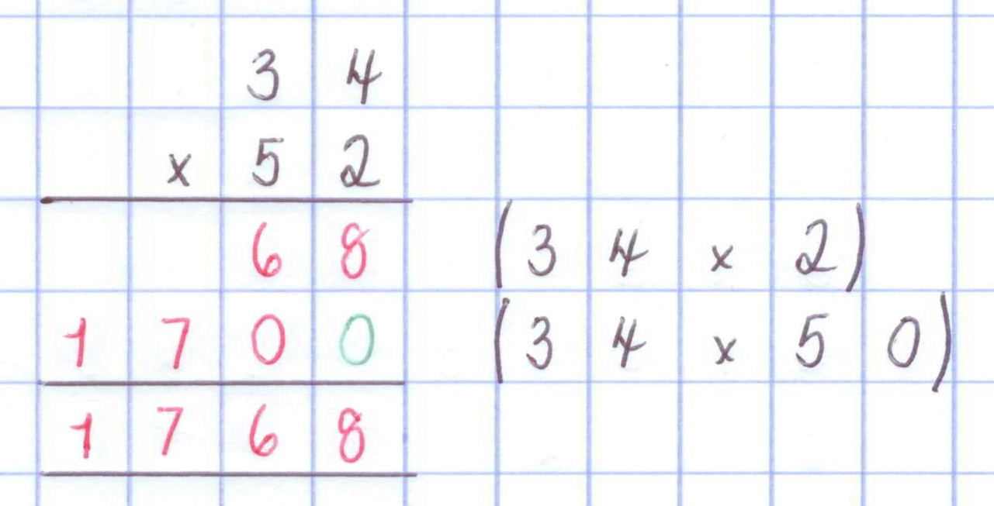  Short Multiplication (Year 4 revision)  Each digit (beginning with the ones and working right to left) is multiplied by the single digit. When the answer to the multiplication in a column exceeds 9, the digit is carried over to the next column and added onto the total of the next multiplication.  Long Multiplication (Year 5 revision)  Each digit in the top number needs to be multiplied by the digits in the bottom number. The two calculations can be written out on the left to guide the children through calculation.  It is important to remember to put down the extra zero when multiplying by 50 as the ‘5’ is in the tens column.  The two calculations are then added together to give the final answer.
Short Division (bus stop method)  (dividing up to 4 digits by 1 digit, including dealing with remainders appropriately)  Key Vocabulary:  divisor: the number of groups dividing by.  dividend: the number being divided.  quotient: how many are in each group.  remainder: what is left over. | 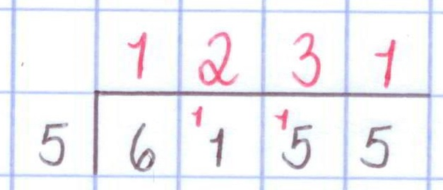  Short Division (Year 4 revision)  Work left to right. For each digit of 6155, calculate ‘how many fives are in the number’. The answer should be written above.  Children will need to use their knowledge of times tables to help them calculate each division.  When a digit in the dividend (number being divided) cannot be exactly divided by the divisor (in this case, 5), there may be a remainder which needs to be carried over to the next digit in the number.  In this case, 6 ÷ 5 = 1 remainder 1  The one is carried to the next column to make 11.  11 ÷ 5 = 2 remainder 1  Th one is carried to the next column to make 15.  15 ÷ 5 = 3.  Finally 5 ÷ 5 = 1  There may be multiple digits carried in one calculation.  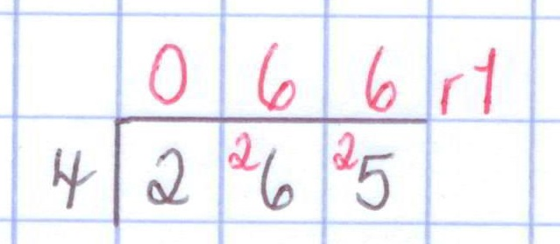  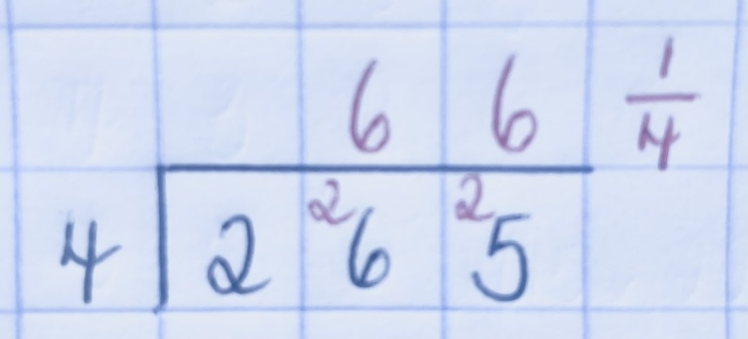  Division with remainders (Year 5 revision)  When the dividend cannot be exactly divided by the divisor, children will need to be able to show remainders. In Year 5, they learn how to show remainders as whole numbers, decimals and fractions.  They will come across problem solving questions which will ask them to interpret remainders appropriately according to the context. For example: If 265 children are going on a trip and each car holds 4 children, how many cars do they need to take all the children?  They will need more cars than necessary in order to fit all children in, so after completing the calculation the children will need to round their answer up to the nearest whole number (67 cars).  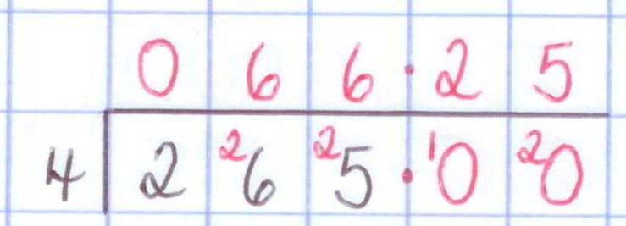
Long Division  Key Vocabulary:  divisor: the number of groups dividing by.  dividend: the number being divided.  quotient: how many are in each group.  remainder: what is left over. | 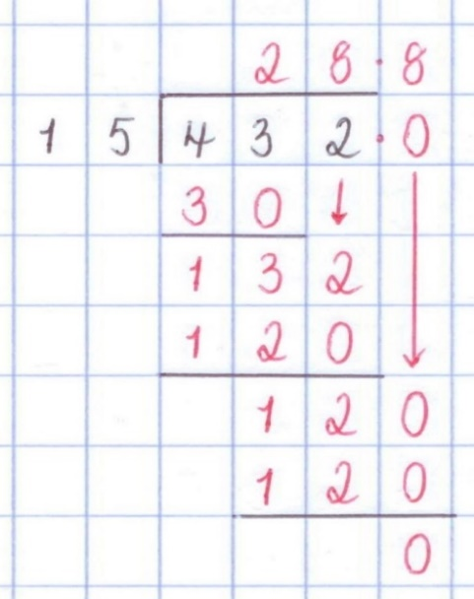  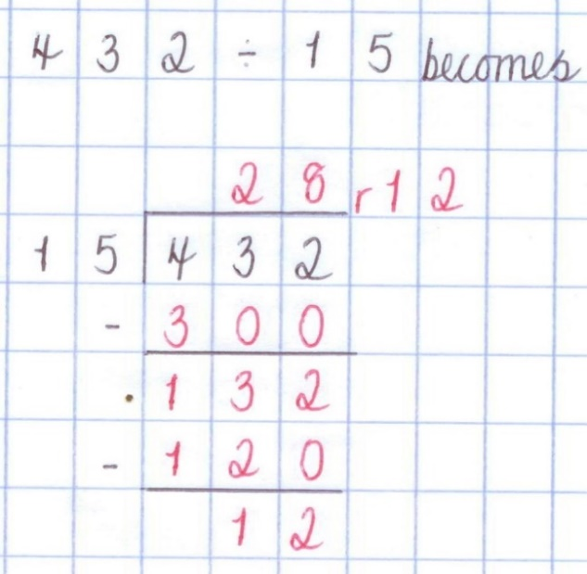  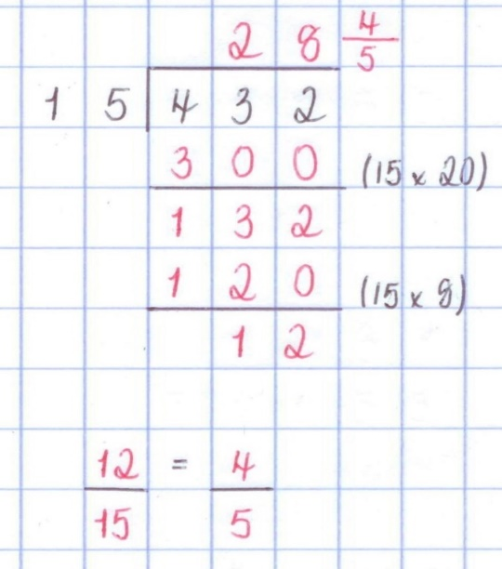  In Year 6, the children will be taught to use long division using a number of different methods (see examples).  Using these examples, the children will be able to calculate and represent remainders as:  - a whole number  - a fraction  - a decimal

Application to problem solving
Once children have mastered the key calculation methods, they are required to use them correctly within a range of problem-solving contexts. This often includes understanding units of measure and selecting the correct operation from a written problem.

Children will be required to engage with a range of word problems, which require them to use and apply methods relating to the four main operations (addition, subtraction, multiplication and division).

In this example, the children are required to find the difference between the combined total of Mount Kilimanjaro and Ben Nevis and Mount Everest. The children would need to use formal methods for adding the heights of Kilimanjaro and Ben Nevis, before subtracting the total from the height of Mount Everest.

Children could use the inverse (opposite) methods to check their answers.

In other questions, the children will be required to use and apply their knowledge of fractions (including decimals and percentages) alongside units of measure (time, length and mass).

Children should use their knowledge of number and fractions to solve these problems.

Application to problem solving
Once children have mastered the key calculation methods, they are required to use them correctly within a range of problem-solving contexts. This often includes understanding units of measure and selecting the correct operation from a written problem.

Other questions are not contextualized, as the example to the left demonstrates.

These questions may require the children to recall, use and apply knowledge, which has been taught in previous years. Throughout school, the children will have learnt how to compare and order numbers.

It is important that children read the question carefully to make sure answers are presented correctly i.e. smallest to largest.
As above, children may be required to use knowledge (such as multiplication and division facts and place value) to solve missing number problems.

It is important for the children to remember that there is often more than one way to correctly answer these questions.
In Year 6, the children may be required to use given information to make calculations or identify numbers. The children should ensure they take time to read the question carefully in order to gain all relevant information.

In some cases, there may be more than one possible correct answer to the question and children may be asked to find all possibilities.
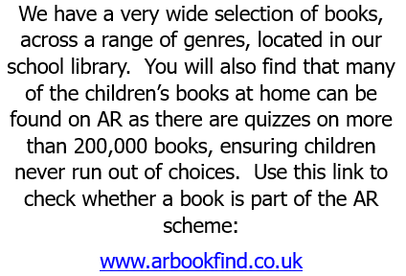
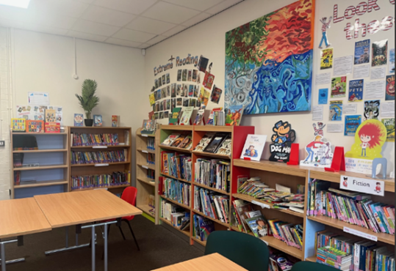
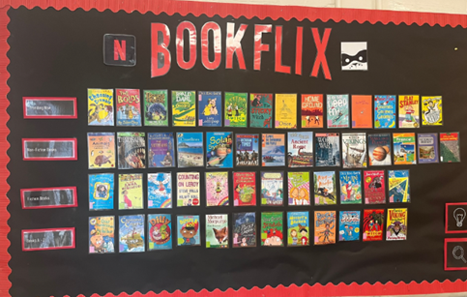
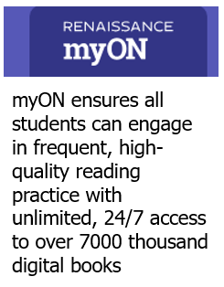
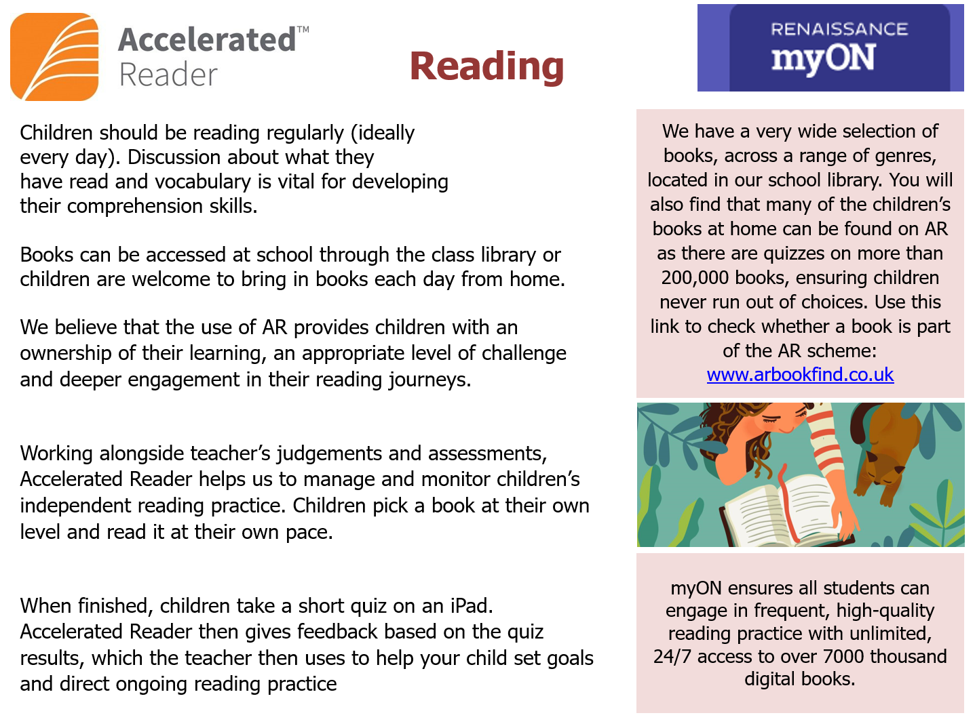
Reading Domains (VIPERS) question examples for reading at home
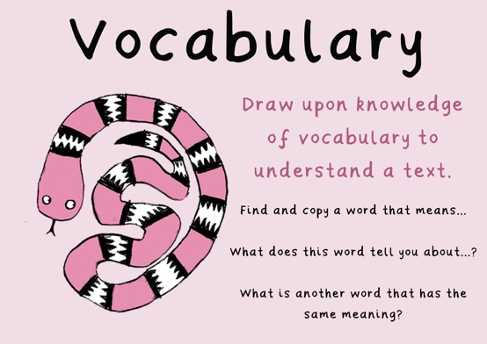 | - What does the word ………. mean in this sentence?  - Find and copy a word which means ……….  - What does this word or phrase tell you about ………?  - Which word in this section do you think is the most important? Why?  - Which of the words best describes the character/setting/mood etc?  - Can you think of any other words the author could have used to describe this?  - Why do you think ………. is repeated in this section? | 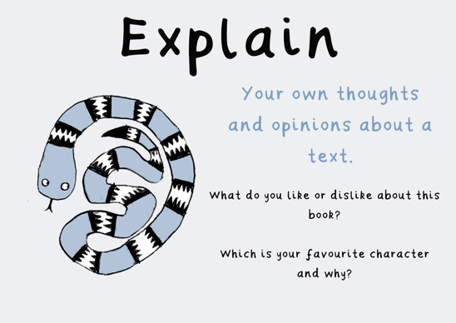 | - Who is your favourite character? Why?  - How do you think you would react if you were in this story?  - Would you like to live in this setting? Why/why not?  - Is there anything you would change about this story?  - Do any of the characters remind you of people you know or characters in other books?
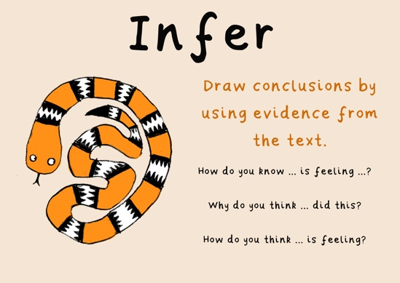 | - Why was……. feeling……..?  - Why did ………… happen?  - Why did ………. say ……….?  - Can you explain why……….?  The key skill when inferring is finding evidence directly from the text to support the inference and explaining how the evidence and inference are linked. | 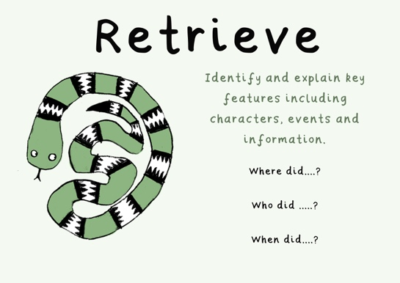 | - What kind of text is this? (fiction, non-fiction, poetry)  - Who did…..?  - Where did…..?  - When did…..?  - What happened when…..?  - Why did …….. happen?  - How did …….?  - How many…..?  - What happened to……?  Encourage scanning back through the text to find the exact wording when answering.
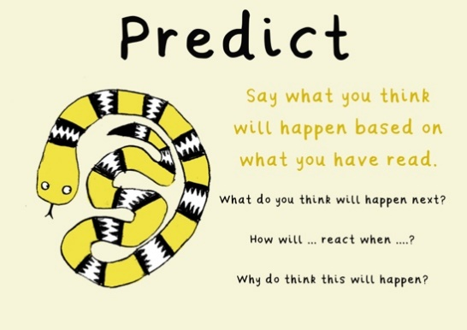 | - Look at the book cover/blurb – what do you think this book will be about?  - What do you think will happen next? What makes you think this?  - How do you think this character might change during the story?  - What is happening? What do you think happened before? What do you think will happen after?  - If there was another chapter at the end of this book, what might happen? | 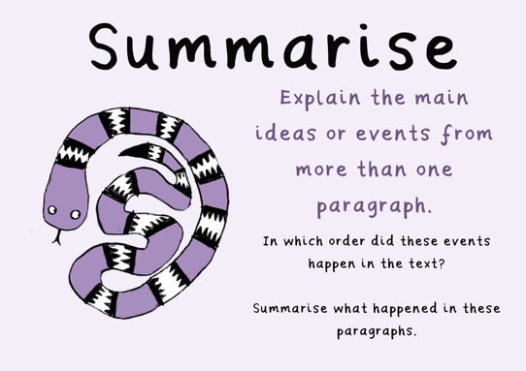 | - Can you explain what has happened in this chapter in 30 words or less?  - What happened after …….?  - What was the first thing that happened in the story?  - Can you identify the three most important facts or points from this text?  - Can you retell the story/chapter?

Year 5 and 6: Recommended Reads

Fantasy
- Joan Aiken, Midnight is a Place
- David Almond, Skellig, Heaven Eyes
- Eion Colfer, Artemis Fowl series, The Supernaturalist, Half Moon
- Investigations
- Susan Cooper, The Dark is Rising sequence
- Chris D’Lacey, Icefire, Shrinking Ralph Perfect, The Salt Pirates of
- Skegness
- Helen Dunmore, Ingo
- Cornelia Funke, Inkheart, Inkspell, The Thief Lord
- Alan Garner, The Owl Service, Elidor
- Alan Gibbons, Warriors of the Raven
- Elizabeth Goudge, Little White Horse
- Anthony Horowitz, The Power of Five series
- Erin Hunter, Warrior Cats series
- Brian Jaques, Redwall
- Diane Wynne Jones, Eight Days of Luke, The Chrestomanci Series
- Elizabeth Kay The Divide, Back to the Divide etc
- Stephen Moore, Tooth and Claw
- William Nicholson, The Wind on Fire Trilogy, The Noble Warriors
- Trilogy
- Jenny Nimmo, Charlie Bone series
- Ian Ogilvy, Measle and the Mallockee
- Christopher Paolini, Eragon, Eldest
- Michele Paver, Wolf Brother, Spirit Walker, Soul Eater
- Terry Pratchet, Johnny and the Bomb, Diggers, The Amazing
- Maurice and His Educated Rodents
- Philip Pullman, His Dark Materials Series
- Philip Reeve, Mortal Engines
- Philip Ridley, Mighty Fizz Chilla
- J. K. Rowling, Harry Potter
- Louis Sachar, Holes, Small Steps
- Angie Sage, Septamus Flyte series
- Ali Sparkes, Shapeshifter series
- Paul Stewart and Chris Riddell, The Edge Chronicles series
- Jonathan Stroud, Golem’s Eye
Fantasy continued…
- Robert Swindells, In the Nick of Time
- G. P. Taylor, Shadowmancer
- Kate Thompson, The Swithchers Trilogy, The Missing Link
- J. R. R.Tolkein, The Hobbit / Lord of the Rings
- Dr Who story books

Adventure
- Jon Blake, The Last Free Cat
- Frank Cottrell Boyce, Millions, Framed, Cosmic
- Melvin Burgess, An Angel for May
- Joe Craig, Jimmy Coates series
- Jamila Gavin, The Blood Stone, Surya Trilogy
- Carl Hiaasen, Hoot
- Charlie Higson, The Young Bond books
- Anthony Horowitz, Alex Rider series
- Sophie Mckenzie, Girl Missing
- Willard Price, Volcano Adventure etc
- Chris Ryan, Alpha Force series
- Ruth Thomas, The Runaways
- Mark Walden, H.I.V.E series
- Jeanette Winterson, Tanglewreck

World War 2
- Nina Bawden, Carrie’s War
- John Boyne, The Boy in the Striped Pyjamas
- The Diary of Anne Frank
- Anne Holm, I am David
- Judith Kerr, When Hitler Stole Pink Rabbit
- Robert Leeson, Tom’s War
- Michele Magorian, Goodnight Mr Tom
- Linda Newberry, Blitz Boys
- Christne Nostlinger, Fly Away Home
- Jill Paton Walsh, Dolphin Crossing
- Robert Westall Blitzcat, The Machine Gunners

Past
- Berlie Doherty, Street Child
- Paul Dowswell, Powder Monkey
- Catherine Fisher, The Oracle
- Terry Jones, The Knight and the Squire, Saga of Erik the Viking
- Caroline Lawrence, The Roman Mysteries
Past continued…
- Rick Riordan, Percy Jackson series
- Matthew Skelton, Endymion Spring
- Eleanor Updale, Montmorency series

Scary
- Maragret Mahy, The Haunting
- Peter J Murray, Mokee Joe series
- Darrren Shan, Cirque Du Freak, The Vampire’s Assisitant
- Justin Sompter, Vampirates series
- Robert Swindells, The Thousand Eyes of Night

Classics
- Frances Hodgson Burnett, The Secret Garden, The Little Princess,
- Little Lord Fauntleroy
- Arthur Conan Doyle, The Lost World
- Alexandre Dumas, The Three Musketeers
- W. E. Johns, Biggles
- C. S. Lewis, Narnia
- L. M. Montgomery, Anne of Green Gables
- E. Nesbit, The Railway Children
- Mary Norton, The Borrowers
- Arthur Ransome, Swallows and Amazons
- Anna Sewell, Black Beauty
- R. L, Stevenson, Treasure Island
- Mark Twain, The Adventures of Tom Sawyer
- Jules Verne, Around the World in 80 Days

Modern Classics
- Richard Adams, Watership Down
- Joan Aiken, The Wolves of Willoughby Chase
- Lynne Read Banks, The Indian in the Cupboard
- Gillian Cross, The Demon Headmaster series, The Great Elephant
- Chase
- Penelope Farmer, Charlotte Sometimes
- Norman Juster, The Phantom Tollbooth
- Jack London, White Fang, Call of the Wild
- Jenny Nimmo, The Snow Spider Trilogy
- Phillipa Pearce, Tom’s Midnight Garden
- Sylivia Voight, The Homecoming
- Laura Ingalls Wilder, Little House on the Prairie
Well-loved authors
- Roald Dahl, Witches
- Geraldine McCaughrean, Stop the Train, The Stones are Hatching, A
- Little Lower than Angels, Peter Pan in Scarlet
- Michael Morpurgo, books for older readers Out of the Ashes, Private
- Peaceful, Alone on the Wide Sea, Adolphus Tips, Why the Whales
- Came
- Jacqueline Wilson, The Illustrated Mum, Vicky Angel, My Sister Jodie

Thought provoking books
- Malorie Blackman, Pig Heart Boy, Tell Me No Lies
- Zizou Corder, Lionboy
- Peter Dickinsnon, The Kin
- Anita Desai, Village by the Sea
- Deborah Ellis, The Breadwinner series
- Adeline Yen Mah, The Chinese Cinderella
Humour
- Dinah Capparucci, Aliens Don’t Eat Dog Food
- Susan Gates, Killer Mushrooms Ate My Gran
- Pete Johnson, Trust Me I’m a Trouble maker
- Diana Wynne, Jones Charmed Life
- Phillip Reeve, Night of the Living Dead, Night of the Living Veg
- Alan Temperley, Harry and the Wrinklies

After Jacqueline Wilson
- Georgia Byng, Molly Moon books
- Cathy Cassidy, Lucky Star, Scarlet
- Sharon Creech, Walk Two Moons, The Wanderer
- Annie Dalton, Angels Unlimited
- Narinder Dhami, Bindi Babes
- Anne Fine, Madame Doubtfire Goggle Eyes, Up on Cloud Nine, Flour
- Babies
- Belinda Hollyer, Everything I Know About You
- Polly Horvath, Everything on a Waffle
After Jacqueline Wilson continued…
- Eva Ibbotson, Journey to the River Sea
- Gwyneth Rees, The Mum Hunt, The Making of May

Barrington Stoke For Older Readers
- Malorie Blackman, Hostage
- Tony Bradman, The Dirty Dozen
- Theresa Breslin, Starship Rescue
- Annie Dalton, Friday Forever
- Mary Hoffman, Virtual Friend
- Mary Hooper, The Genie
- Ann Jungman, Resistance
- Michael Lawrence, Young Dracula
- Lynne Markham, Cinderalf
- Anthony Masters, Tod in Biker City
- Alison Prince, Screw Loose
- Rosie Rushton, Life Line
- Jeremy Strong, Mad Iris
- Hazel Townson, Lift Off, The Secret Room

Year 6: Spelling Patterns and Words
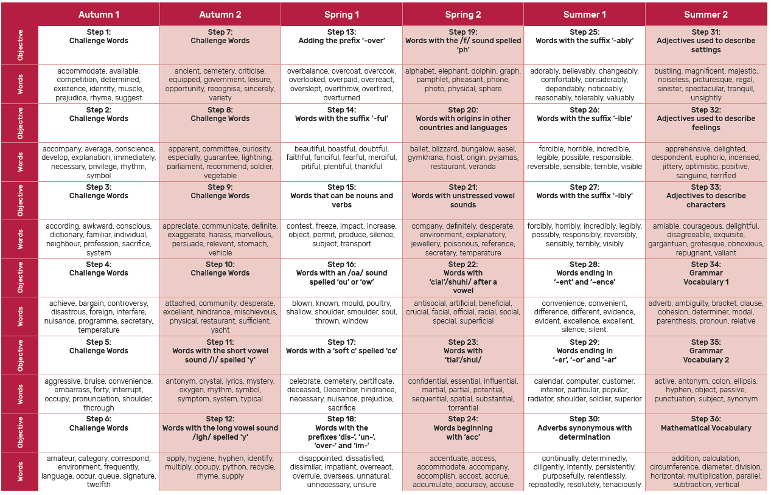

Spelling Practice Methods



